SET 26: STUDENT DATA ANALYSIS USING R
AIM
To analyze student academic performance using Math scores, Science scores, study hours, gender, and examination dates using R programming.
DATASET
Student ID | Gender | Study Hours | Attendance | Math Score | Science Score | Exam Date
S01 | Male | 2.0 | 78 | 62 | 65 | 2025-01-10
S02 | Female | 3.5 | 90 | 80 | 85 | 2025-01-10
S03 | Male | 1.5 | 70 | 55 | 58 | 2025-02-12
S04 | Female | 4.0 | 95 | 90 | 92 | 2025-02-12
S05 | Male | 2.8 | 85 | 72 | 74 | 2025-03-15
S06 | Female | 3.0 | 92 | 82 | 86 | 2025-03-15
QUESTION 1: HISTOGRAM AND BOXPLOT
Aim: To analyze the distribution of Math scores and compare Science scores by gender.
Program:
gender <- c("Male","Female","Male","Female","Male","Female")
math <- c(62,80,55,90,72,82)
science <- c(65,85,58,92,74,86)
par(mfrow=c(1,2))
hist(math, col="skyblue",
main="Math Scores", xlab="Math Score")
boxplot(science ~ gender, col=c("orange","lightgreen"),
main="Science by Gender",
xlab="Gender", ylab="Science Score")
par(mfrow=c(1,1))
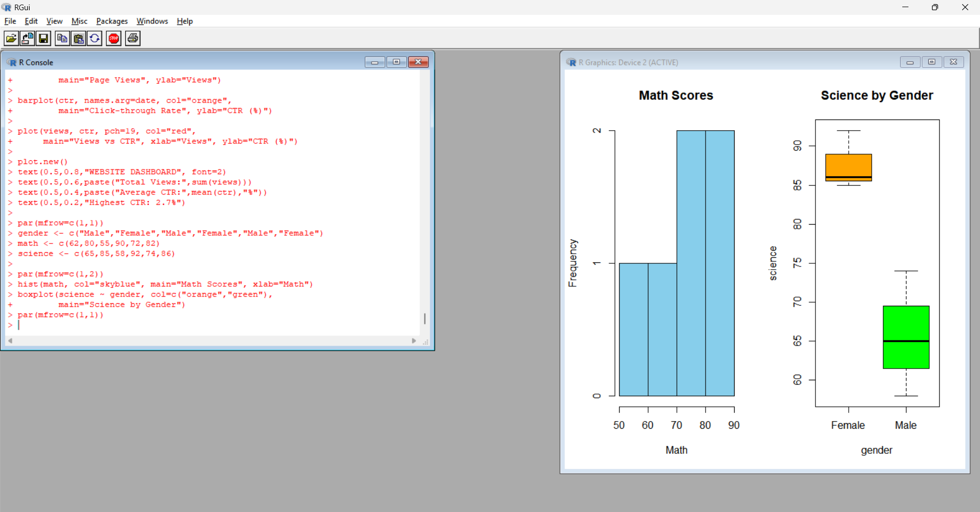
Procedure:
- Enter Math scores, Science scores, and gender.
- Create a histogram of Math scores.
- Create a boxplot of Science scores grouped by gender.
- Add suitable titles and axis labels.
Output: A histogram and a boxplot displayed in the RStudio Plots window.
Observation: Math scores range from 55 to 90. Female students have higher Science scores than male students in this sample.
QUESTION 2: STUDY HOURS AND MATH SCORES
Aim: To examine the relationship between study hours and Math scores using a scatter plot and regression line.
Program:
hours <- c(2,3.5,1.5,4,2.8,3)
math <- c(62,80,55,90,72,82)
gender <- c("Male","Female","Male","Female","Male","Female")
cols <- ifelse(gender=="Male","blue","red")
plot(hours, math, col=cols, pch=19,
main="Study Hours vs Math",
xlab="Study Hours", ylab="Math Score")
abline(lm(math ~ hours), col="black", lwd=2)
legend("topleft", c("Male","Female"),
col=c("blue","red"), pch=19)
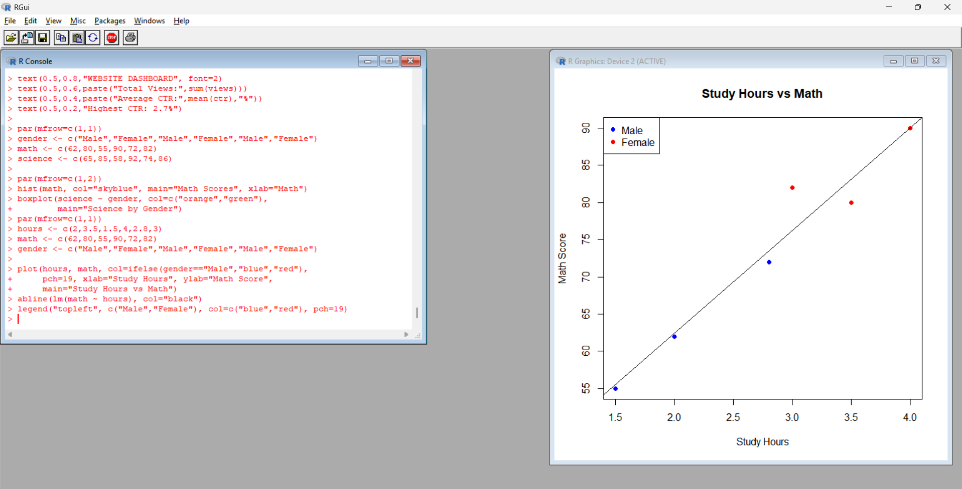
Procedure:
- Enter study hours, Math scores, and gender.
- Create a scatter plot with study hours on the X-axis and Math scores on the Y-axis.
- Use different colors for male and female students.
- Add a regression line using abline() and lm().
Output: A scatter plot with gender-based colors and a regression line.
Observation: The data show a positive relationship between study hours and Math scores. Students who study longer generally have higher Math scores in this sample.
QUESTION 3: MONTHLY AVERAGE MATH SCORES WITH MOVING AVERAGE
Aim: To calculate monthly average Math scores and visualize their trend using a moving average.
Program:
date <- as.Date(c("2025-01-10","2025-01-10",
"2025-02-12","2025-02-12",
"2025-03-15","2025-03-15"))
math <- c(62,80,55,90,72,82)
month <- format(date,"%Y-%m")
avg <- aggregate(math, by=list(Month=month), mean)
names(avg)[2] <- "Average"
print(avg)
plot(1:3, avg$Average, type="b", pch=19,
xaxt="n", col="blue",
main="Monthly Average Math Scores",
xlab="Month", ylab="Average Score")
axis(1, at=1:3, labels=avg$Month)
ma <- stats::filter(avg$Average, rep(1/3,3), sides=2)
lines(1:3, as.numeric(ma), col="red", lwd=2)
legend("topleft",
c("Monthly Average","Moving Average"),
col=c("blue","red"), lty=1)
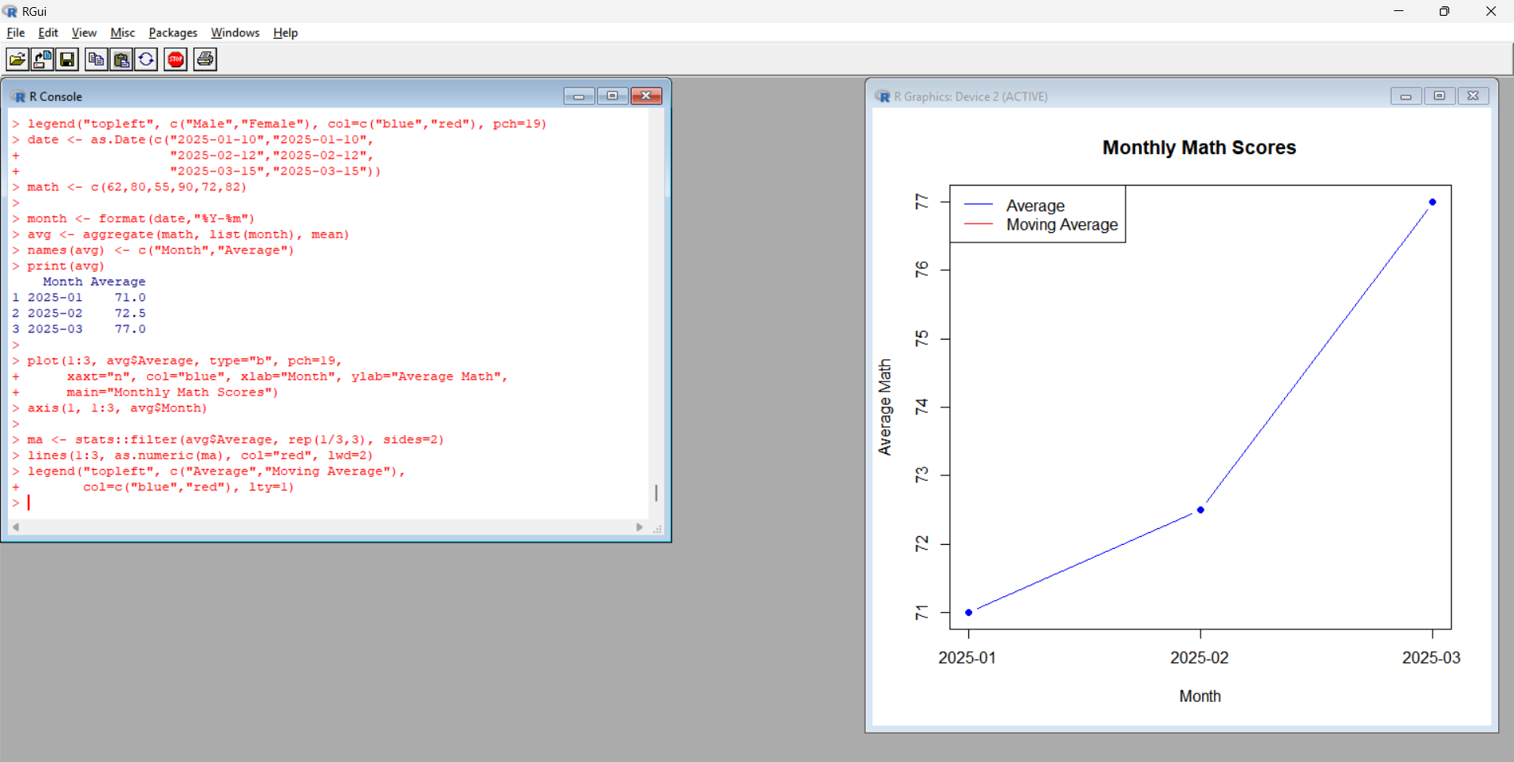
Procedure:
- Convert examination dates into Date format.
- Extract the month from each date.
- Calculate monthly average Math scores using aggregate().
- Plot monthly averages and add a centered three-month moving average.
Output: A line chart showing monthly average Math scores and the moving-average trend.
Observation:
Month | Average Math Score
January 2025 | 71
February 2025 | 72.5
March 2025 | 77
The average Math score increases across the three months. Since only three monthly averages are available, the centered three-month moving average has only one valid value.
QUESTION 4: STUDENT PERFORMANCE DASHBOARD
Aim: To create a dashboard summarizing student academic performance using multiple plots in R.
Program:
id <- c("S01","S02","S03","S04","S05","S06")
gender <- c("Male","Female","Male","Female","Male","Female")
math <- c(62,80,55,90,72,82)
science <- c(65,85,58,92,74,86)
par(mfrow=c(2,2))
barplot(tapply(math,gender,mean),
col=c("skyblue","orange"),
main="Average Math by Gender",
ylab="Score")
barplot(math, names.arg=id, col="lightgreen",
main="Math Scores", ylab="Score")
barplot(science, names.arg=id, col="pink",
main="Science Scores", ylab="Score")
plot(math, science, pch=19, col="blue",
main="Math vs Science",
xlab="Math Score", ylab="Science Score")
par(mfrow=c(1,1))
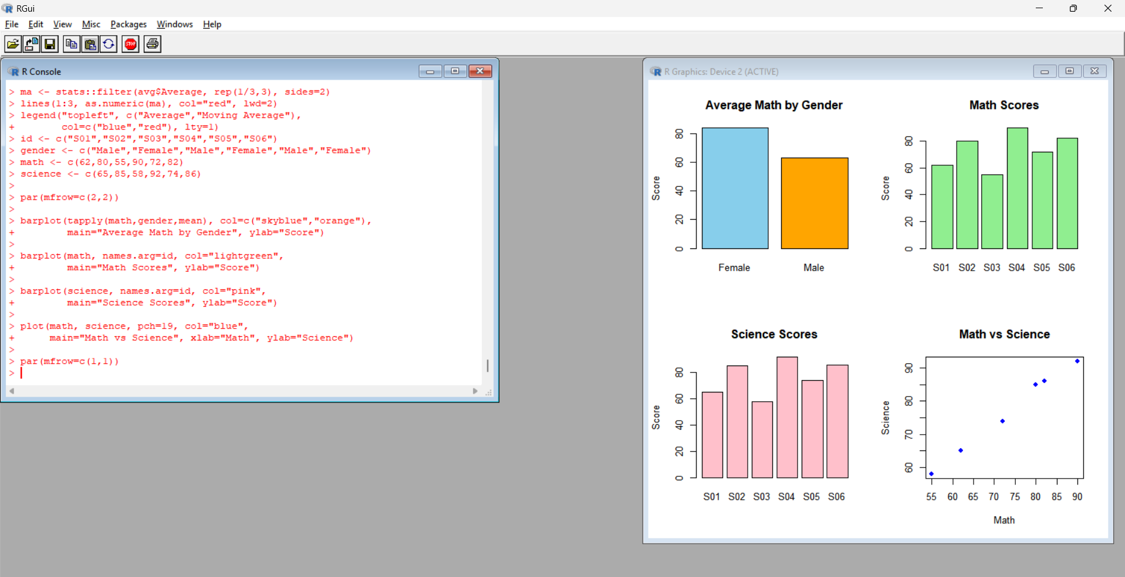
Procedure:
- Calculate average Math scores by gender.
- Create a bar chart of individual Math scores.
- Create a bar chart of individual Science scores.
- Plot Math scores against Science scores.
- Arrange all four plots using par(mfrow=c(2,2)).
Output: A dashboard containing four plots for comparing student academic performance.
Observation: The dashboard helps compare Math and Science scores across students and genders. It also helps examine the relationship between the two subjects.
RESULT
Student academic performance was analyzed using a histogram, boxplot, scatter plot, monthly average trend, and dashboard in R. The results show an increase in monthly average Math scores and a positive relationship between study hours and Math scores in the given sample.

